plmOn License Key Procedures

Disclaimers 2
Retrieving a plmOn Serial Number 2
Applying a plmOn License Key 4

Disclaimers
- In order to generate a plmOn License Key, the unique Serial Number must first be retrieved from each of the Client’s Web Servers. Retrieving the unique Serial Number requires that the plmOn login page be disabled momentarily. Because of this, it is recommended that a time be scheduled with the Client when this action will least disrupt the plmOn users.
- In order to apply a new License Key, the plmOn login page must be disabled momentarily. Because of this, it is recommended that a time be scheduled with the Client when this action will least disrupt the plmOn users.

Retrieving a plmOn Serial Number
- Remote to the Client’s environment.
- Locate the “Config” folder for the desired plmOn environment.
- Inside the “Config” folder, if there is not already a “Backup” folder of some sort, create one.
- In the “Config” folder, create a copy of the current “License.config” file.
- Rename the copy file to “License_backup_20100707.config”, where the numerical portion of the name is the current date.
- Move the copy file into the “Backup” folder.
- Open the original “License.config” file.
Note: If you are on a Windows 2008 Server, to modify the “License.config” file, you may need to open the Notepad application as Administrator. To do so:
  - Click the “Start” button.
  - In the search box, type “Notepad”.
  - Right-click the Notepad application icon and choose “Run as administrator”.
  - Click on “File > Open”, navigate to the “License.config” file and open it.
- In the “License.config” file, locate the key named “LicenseNumber”.
- Remember the current “value” of the “LicenseNumber” key.
- Change the “value” of the “LicenseNumber” key to the new number of users the Client will be licensed for. (For example, if the Client is now going to be licensed for 51 plmOn users, change the “value” to “51”.)
- “Save” your change to the “License.config” file.
- Open Internet Explorer and navigate to the plmOn login page for the environment you are working with. You should see an “Invalid License Key” message like the following. (If you do not, you have either changed the wrong “License.config” file, or you have navigated to the wrong login page.)
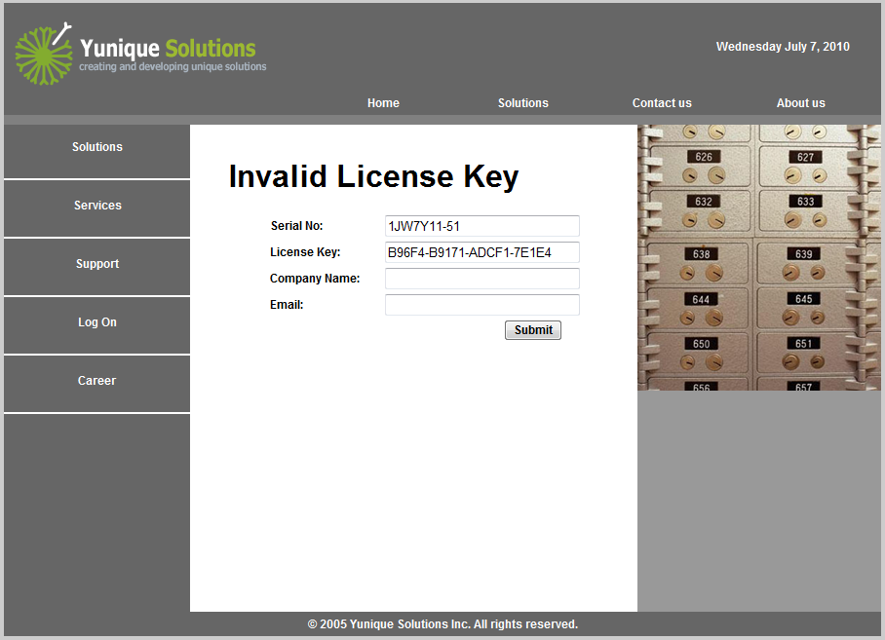
- Highlight and copy the “Serial No” value exactly as it is on screen.
- Save this “Serial No” value in a new Notepad text file.
- In the current “License.config” file, change the “value” of the “LicenseNumber” key back to the original number that you remembered in Step 8 and again “Save” your change.
- In Internet Explorer, navigate again to the plmOn login page for the environment you are working with to make sure that the normal login page comes up successfully. If it does not, possible reasons may be:
  - You did not “Save” your change after reverting the “value” of the “LicenseNumber” key back to its original number.
  - You did not revert the “value” of the “LicenseNumber” key back to its original number
  - You changed something else in the “License.config” file.
If you find yourself in this situation, take the contents of the backup “License.config” file and restore it to the current “License.config” file.
- Attach the new Notepad text file, which contains the retrieved “Serial No”, to an email and send it to Dawn Bowers (dawn.bowers@gerberscientific.com).

Applying a plmOn License Key
- Dawn Bowers (dawn.bowers@gerberscientific.com) will supply a new License Key for the appropriate Web Server of the Client’s environments. The License Key should be contained in a Notepad text file, attached to the email.
- Remote to the Client’s environment.
- Locate the “Config” folder for the desired plmOn environment.
- Inside the “Config” folder, if there is not already a “Backup” folder of some sort, create one.
- In the “Config” folder, create a copy of the current “License.config” file.
- Rename the copy file to “License_backup_20100707.config”, where the numerical portion of the name is the current date.
- Move the copy file into the “Backup” folder.
- Open the original “License.config” file.
Note: If you are on a Windows 2008 Server, to modify the “License.config” file, you may need to open the Notepad application as Administrator. To do so:
  - Click the “Start” button.
  - In the search box, type “Notepad”.
  - Right-click the Notepad application icon and choose “Run as administrator”.
  - Click on “File > Open”, navigate to the “License.config” file and open it.
- In the “License.config” file, locate the key named “LicenseNumber”.
- Change the “value” of the “LicenseNumber” key to the new number of users the Client will be licensed for. (For example, if the Client is now going to be licensed for 51 plmOn users, change the “value” to “51”.)
- “Save” your change to the “License.config” file.
- Open Internet Explorer and navigate to the plmOn login page for the environment you are working with. You should see the “Invalid License Key” message again. This is good! (If you do not, you have either changed the wrong “License.config” file, or you have navigated to the wrong login page.)
- In the “License.config” file, locate the key named “LicenseKey”.
- Change the “value” of the “LicenseKey” key to the new License Key number provided by Dawn Bowers.
- In Internet Explorer, navigate again to the plmOn login page for the environment you are working with to make sure that the normal login page comes up successfully. If it does not, possible reasons may be:
- You did not “Save” your change after updating the “value” of the “LicenseKey” key.
- The “value” of the “LicenseNumber” key is incorrect.
- The “value” of the “LicenseKey” key is incorrect.
- You changed something else in the “License.config” file.
If you find yourself in this situation, take the contents of the backup “License.config” file and restore it to the current “License.config” file and try again.

